**Industrialization and the Suez Canal**

By the beginning of the 1800s, the Industrial Revolution was in full swing in Great Britain. Helped by machines, people were producing goods at a rate unimaginable a few decades earlier. This increased production created a demand for raw materials, many of which Great Britain did not have. Furthermore, rapid industrialization was creating a surplus of manufactured goods, making Britain eager to find fresh markets for its products.

Great Britain looked to its empire, particularly the colony of India, to solve its economic problems. With raw materials in abundant supply, the colonies could supply vast quantities of raw materials such as cotton, jute, and raw silk that Great Britain’s industries needed to produce textiles and other manufactured goods.

The colonies were also ideal markets for British goods. Lacking industrialization, the colonies still made products by hand. Products such as handwoven fabric were very expensive. Machine-made British products were much lower in price. Great Britain’s colonies represented a huge, untapped market for manufactured goods – from cotton fabric and clothing to books, paper, arms, ammunition, hardware, porcelain, and umbrellas.

**Overcoming Great Distances**

Finding answers to Great Britain’s economic problems still left one big geographic question unanswered: How could raw materials and unfinished goods be transported between Britain and its colonies, especially India? The shortest route in operation from London to Calcutta was 11,700 miles around the Cape of Good Hope in southern Africa.

Was there a shorter route? The Red Sea looked like a promising possibility. In 1830, a British steamship sailed from Bombay, India to the port of Suez for the first time. By 1835, an overland route had been set up between Suez and Cairo. Although the journey was time consuming, it shaved a few weeks off the 113 days needed to travel from Great Britain to Calcutta by way of the Cape of Good Hope.

A canal was the obvious next step to improve this link with India. The terrain from Suez to the Mediterranean was mostly a flat expanse of sand and using the dry lake beds that lay across the isthmus would shorten the digging. But the British decided against building a canal. They already controlled the route around the Cape of Good Hope, they reasoned, whereas the Suez Canal route led though part of the Ottoman Empire. A canal would also invite competition for British markets in India and the Far East, since Britain would not be able to stop other countries from using it.

**A Canal is Dug**

France saw the possibilities that Great Britain dismissed. A private French company began digging the canal at Suez in 1859 and completed the work 10 years later. Its route was 105 miles long and took advantage of the dry lakes by flooding them with seawater. Millions of tons of earth had to be excavated to complete the canal, and millions more had to be dredged out every 15 years thereafter just to keep the waterway free of drifting sand. Most of the labor was performed by as many as 1.5 million Egyptians. Many of them were corvee laborers, unpaid workers who were forced to work on the project as a form of taxation. Thousands died over the course of 10 years.

The canal builders faced a variety of engineering difficulties. One of the most critical was providing freshwater for the workers constructing the canal through more than 100 miles of desert. The solution was to build a freshwater canal side by side with the seawater navigation canal. While the freshwater canal was under construction, camels and donkeys were used to carry water to a point where it could be loaded on barges and floated to the workers. Later, the engineers built two plants for desalinating, or taking the salt out of the sea water. The two plants provided enough water to meet the workers’ needs until the freshwater canal was completed.

Was the Suez Canal worth the effort? In 1870, the year after the canal opened, only 486 ships used it. The number rose steadily every year, however, until it passed 2,000 in 1880. The British found themselves using it more than all other nations combined because of the savings in distance and time to India and the Far East. As early as 1871, 65 percent of the canal’s traffic was British. Travelling through the canal made the distance from Calcutta to London only 7,900 miles – almost 4,000 miles less in distance and 40 percent less time than the route around the Cape of Good Hope.

The British were quick to realize, after the fact, what the new canal meant to their empire. One of those who commented on the importance of the new waterway was the Prince of Wales, who passed through the canal in 1875 on his way to India. “It is an extraordinary pity,” he observed, “that is was not made by an English company and kept in our hands, because it is our highway to India.”

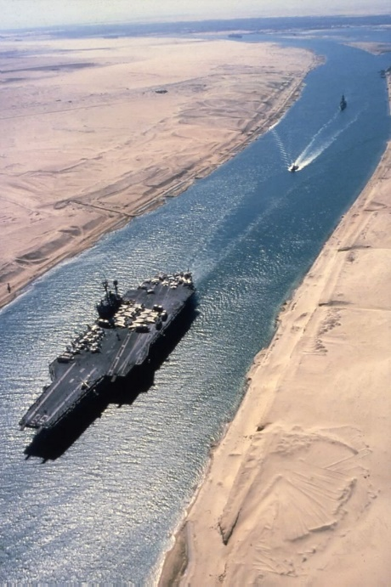

Although the British had missed their chance to build the Suez Canal, they soon found a way to make up for their mistake. When the ruler of Egypt went bankrupt, Britain bought out his 44 percent share in the canal. Not content with legal part ownership, in 1882 Britain seized control of Egypt away from the Ottoman Empire. This takeover would ensure absolute control of its link to India.

**The Canal in the Twentieth Century**

In the early 1900s, oil from the Middle East began to be in demand in Europe and the United States. In just a few decades, Europe came to depend upon Middle Eastern oil for fuel to run its transportation, machinery, and electrical power. Much of the oil was shipped through the Suez Canal.

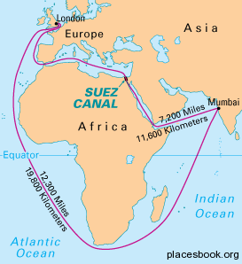

Name: Quang Huynh

1. **Based on the reading, what were some of the economic effects of the Industrial Revolution in England?** Some economic effects of the Industrial Revolution in England were the price splurge of manufactured products due to the quantity. There was too much industrialization and that means, the more there is of something, the less money it would be. In contrast, if there was not much of something and the demand is high, then the price will be expensive. The surplus of manufactured products lowered the price of them and also required more raw materials to make them.

2. **Why did Great Britain look to India to solve some of its economic problems?** GreatBritain looked towards India to solve some of its economic problems since India had an abundant source of resources and materials needed to manufacture British products.

3. **What geographic issues did Britain face?** The geographic issue the British faced is transporting the raw materials from India to Britain. The shortest known route was even 11,700 miles apart from each other. There were no other routes that were faster, so people had to manually dig out a canal to get a faster route.

4. **Why did the British decide against digging a canal between Suez and Cairo?** The British decided against digging a canal between the Suez and Cairo because they already controlled another route, and the canal would lead straight through the Ottoman Empire. Furthermore, there would be a lot of competition if a canal were constructed.

5. **What country eventually decided to dig the canal? Who were the workers? Describe their conditions.** The country that eventually decided to dig the canal were the French. A private French company began to dig the canal and the workers were mainly Egyptian. These workers were corvee laborers who were unpaid and forced to work on the canal as a form of taxation.

6. **How did the Suez Canal aid the British?** The Suez Canal aided the British since it saved a bunch of time transporting between India and Britain. It saved time and distance traveling for them, and the British used the canal more than the other nations.

7. **Explain how the Suez Canal eventually came to be under British control.** The Suez Canal would eventually come under British rule after they regretted not building the canal. When the Egyptian ruler went bankrupt, the British would buy some shares and partly own the canal. But still not satisfied, the British would conquer Egypt away from the Ottoman Empire and control the Suez Canal.

8. **Why did the Suez Canal continue to be important in the 20th century?** The Suez Canal would continue to be important in the 20th century since the Western Powers would require oil from the Middle East to operate their machinery. A lot of the oil is shipped through the Suez Canal.